IOP-OSPMC-140228301
Multi Crystalline Solar Modules
140W / 22.20V / 8.36A
Specification
Maximum Power Rating (W) ± 3% | 140W
Open Circuit Voltage (Voc) | 22.20V
Short Circuit Current (Isc) | 8.36A
Maximum Power Voltage (Vmp) | 18.03V
Maximum Power Current (Imp) | 7.77A
Module Efficiency (%) | 13.89%
Maximum System Voltage | 1000VDC
Output Terminal | Cable with Tyco Connectors
Weight | 11.9Kgs / 26.24lbs
Dimensions (L x W x H) | 1019 x 989 x 39 mm (40.12” x 38.94” x 1.54”)
Number of Cells | 36 in a 6 x 6 matrix connected in series
Solar Cell Type | Multi Crystalline Silicon
Solar Cell Size | 6” / 156 x 156 mm
Temperature Coeff. of Voc | -0.33 %/K
Temperature Coeff. of Isc | 0.05 %/K
Temperature Coeff. of Pmax | -0.43 %/K
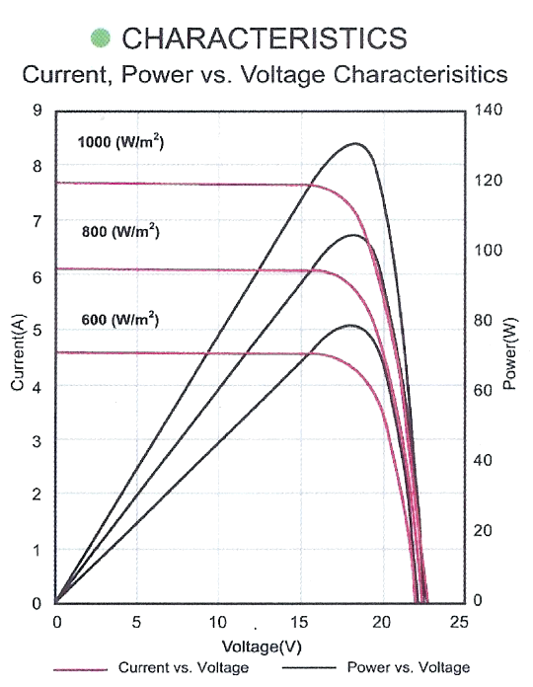
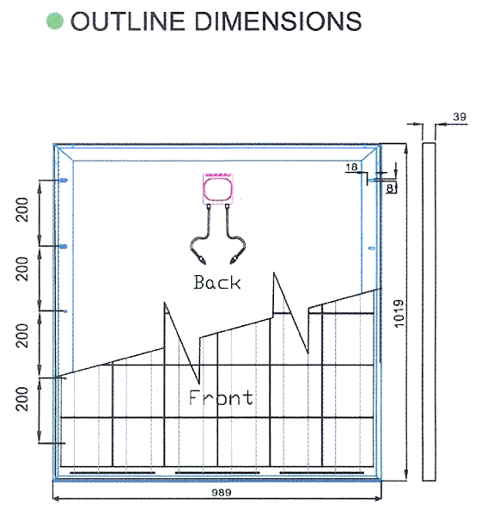
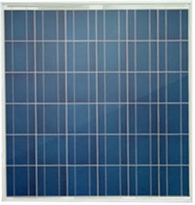
STC: irradiance level 1000W/m2, spectrum AM 1.5 and Cell temperature 25℃

