IOP-OSPMC-190328001
Multi Crystalline Solar Modules
190W / 32.49V / 8.00A
Specification
Maximum Power Rating (W) ± 3% | 190W
Open Circuit Voltage (Voc) | 32.49V
Short Circuit Current (Isc) | 8.00A
Maximum Power Voltage (Vmp) | 25.57V
Maximum Power Current (Imp) | 7.42A
Module Efficiency (%) | 12.84%
Maximum System Voltage | 1000VDC
Output Terminal | Cable with Tyco Connectors
Weight | 17.5Kgs / 38.58lbs
Dimensions (L x W x H) | 1496 x 989 x 39 mm (58.90” x 38.94” x 1.54”)
Number of Cells | 54 in a 6 x 9 matrix connected in series
Solar Cell Type | Multi Crystalline Silicon
Solar Cell Size | 6” / 156 x 156 mm
Temperature Coeff. of Voc | -0.34 %/K
Temperature Coeff. of Isc | 0.06 %/K
Temperature Coeff. of Pmax | -0.40 %/K
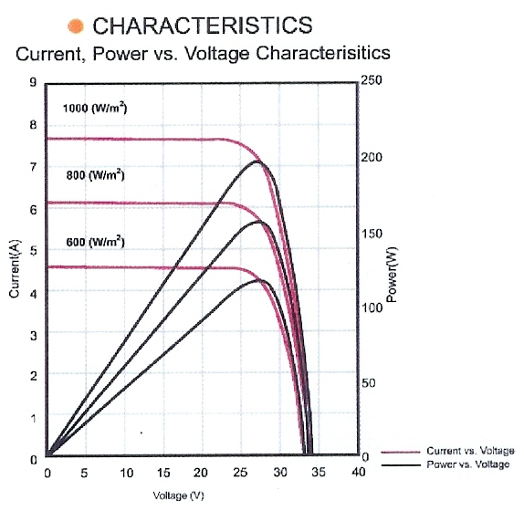
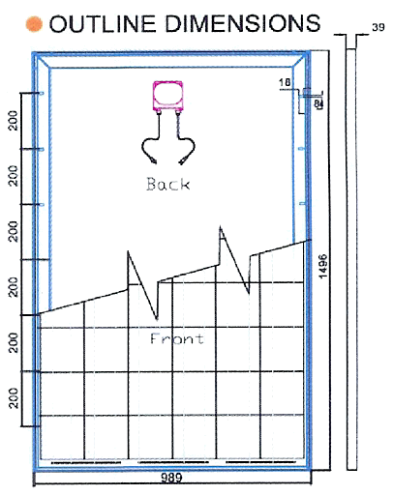

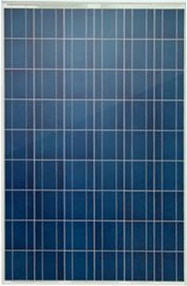

STC: irradiance level 1000W/m2, spectrum AM 1.5 and Cell temperature 25℃

