IOP-OSPMC-200328101
Multi Crystalline Solar Modules
200W / 32.89V / 8.18A
Specification
Maximum Power Rating (W) ± 3% | 200W
Open Circuit Voltage (Voc) | 32.89V
Short Circuit Current (Isc) | 8.18A
Maximum Power Voltage (Vmp) | 26.31V
Maximum Power Current (Imp) | 7.60A
Module Efficiency (%) | 13.52%
Maximum System Voltage | 1000VDC
Output Terminal | Cable with Tyco Connectors
Weight | 17.5Kgs / 38.58lbs
Dimensions (L x W x H) | 1496 x 989 x 39 mm (58.90” x 38.94” x 1.54”)
Number of Cells | 54 in a 6 x 9 matrix connected in series
Solar Cell Type | Multi Crystalline Silicon
Solar Cell Size | 6” / 156 x 156 mm
Temperature Coeff. of Voc | -0.34 %/K
Temperature Coeff. of Isc | 0.06 %/K
Temperature Coeff. of Pmax | -0.40 %/K
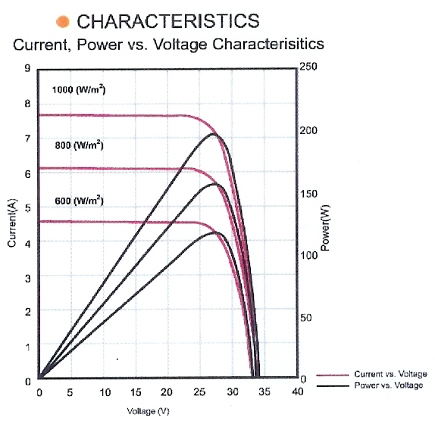
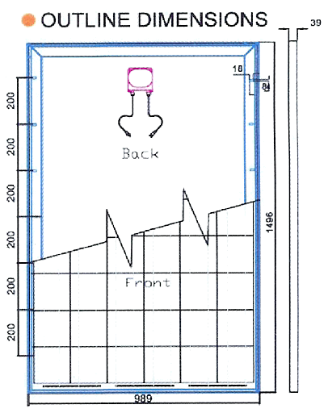
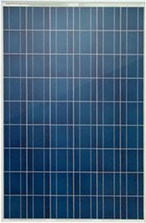

STC: irradiance level 1000W/m2, spectrum AM 1.5 and Cell temperature 25℃

