IOP-OSPMC-215368001
Multi Crystalline Solar Modules
215W / 36.26V / 8.03A
Specification
Maximum Power Rating (W) ± 3% | 215W
Open Circuit Voltage (Voc) | 36.26V
Short Circuit Current (Isc) | 8.03A
Maximum Power Voltage (Vmp) | 28.70V
Maximum Power Current (Imp) | 7.47A
Module Efficiency (%) | 13.14%
Maximum System Voltage | 1000VDC
Output Terminal | Cable with Tyco Connectors
Weight | 18.8Kgs / 41.45lbs
Dimensions (L x W x H) | 1655 x 989 x 39 mm (65.50” x 38.94” x 1.54”)
Number of Cells | 60 in a 6 x 10 matrix connected in series
Solar Cell Type | Multi Crystalline Silicon
Solar Cell Size | 6” / 156 x 156 mm
Temperature Coeff. of Voc | -0.34 %/K
Temperature Coeff. of Isc | 0.06 %/K
Temperature Coeff. of Pmax | -0.40 %/K
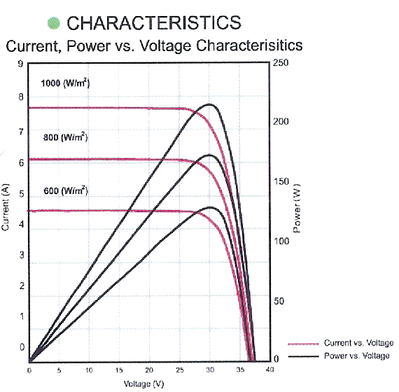
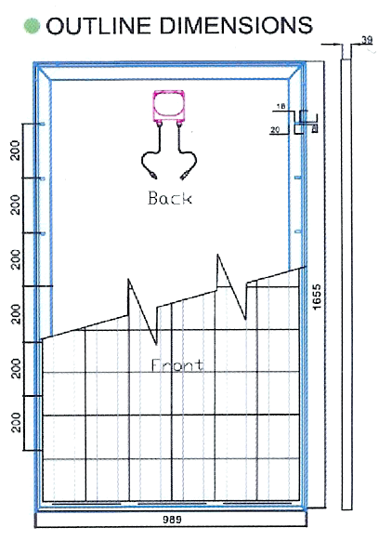
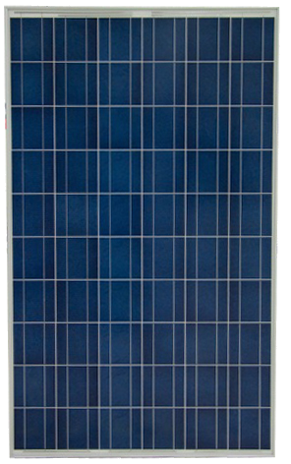

STC: irradiance level 1000W/m2, spectrum AM 1.5 and Cell temperature 25℃

